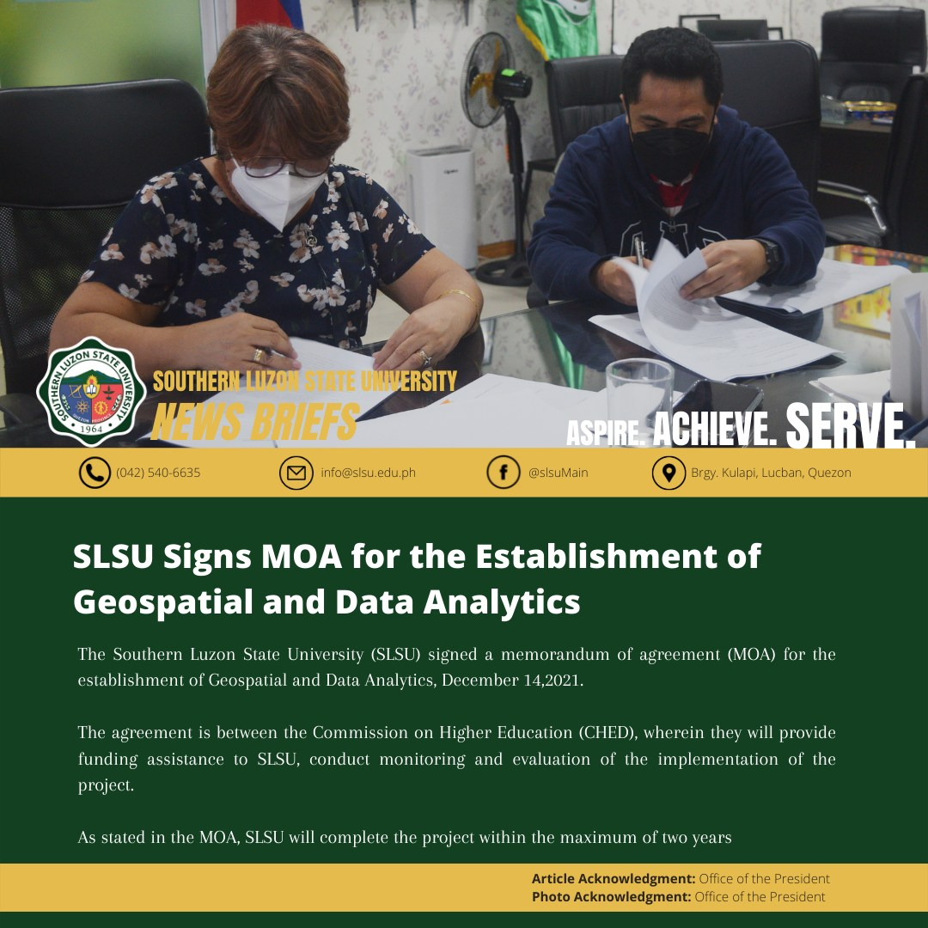

**MOA signing for CHED – IDIG Project**

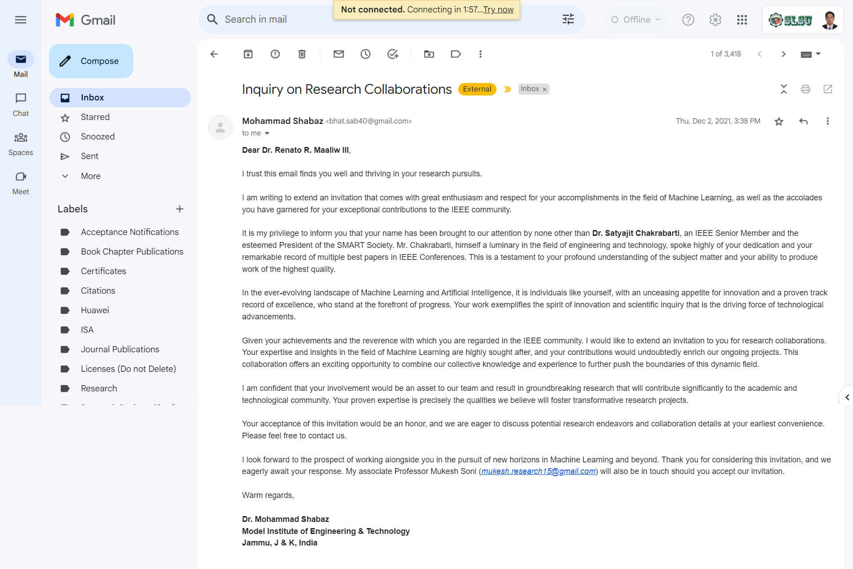

**Research Collaborations with Foreign Authors**

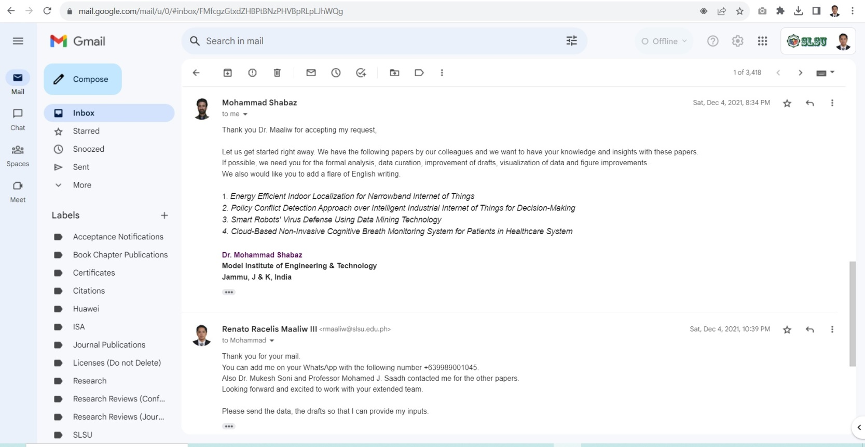

**Research Collaborations with Foreign Authors**

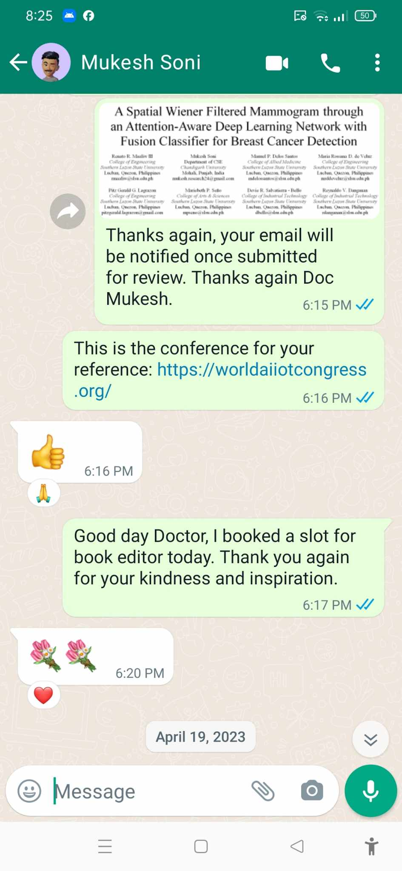

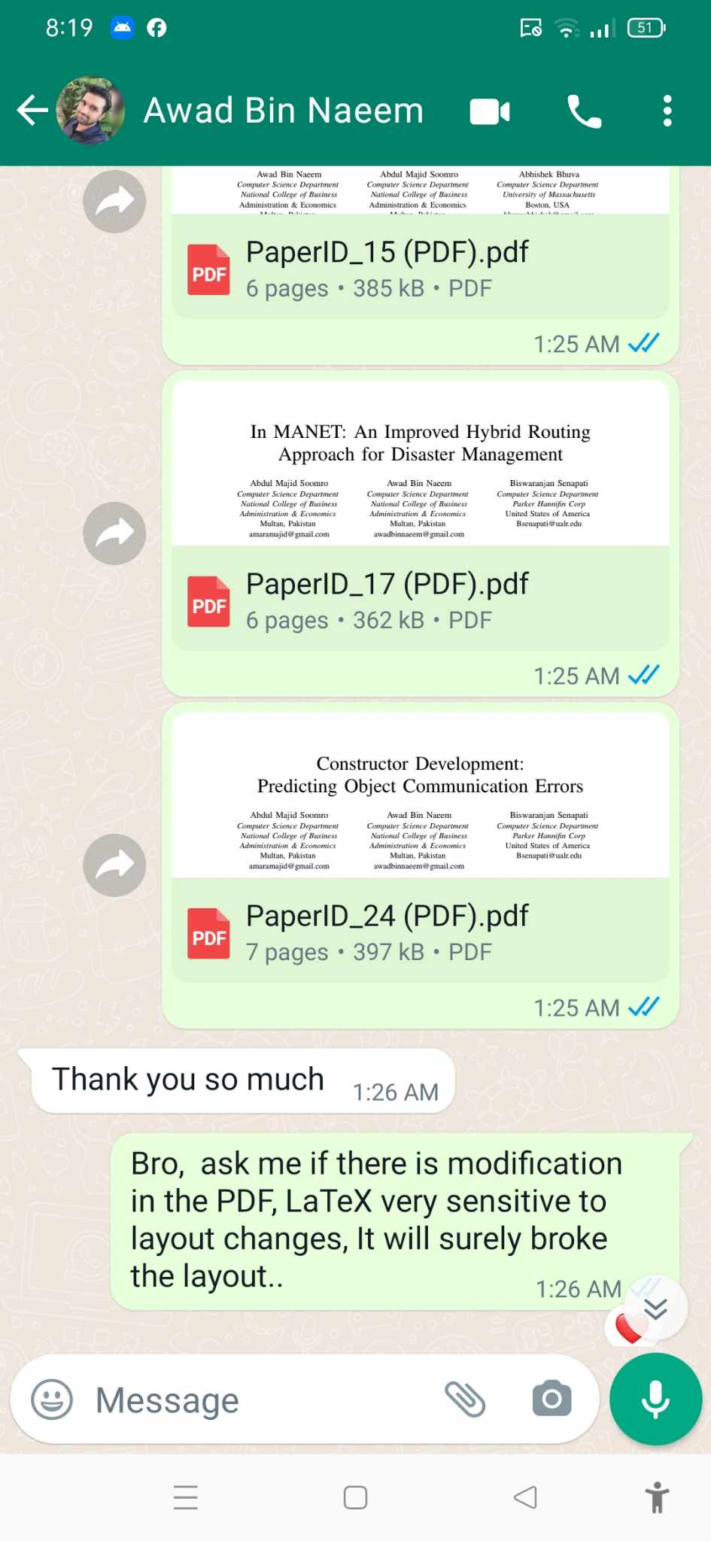

**Research Collaborations with Foreign Authors**

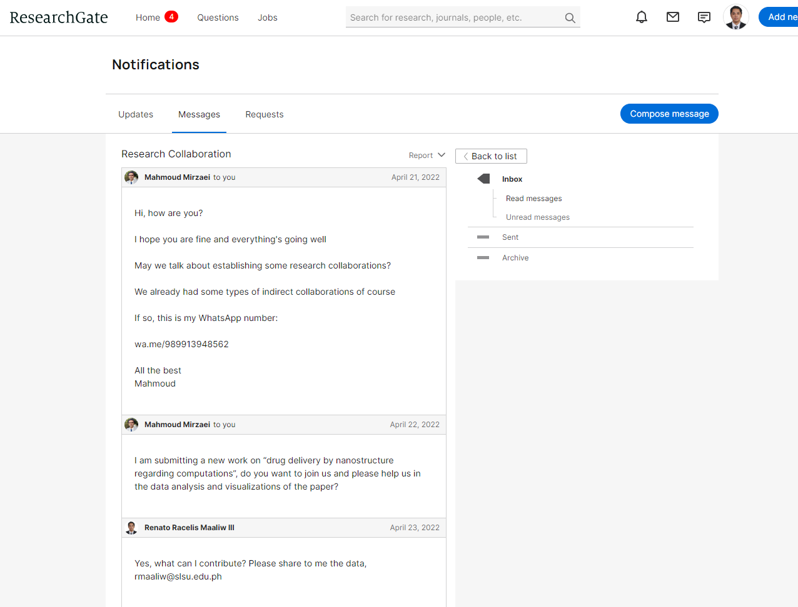

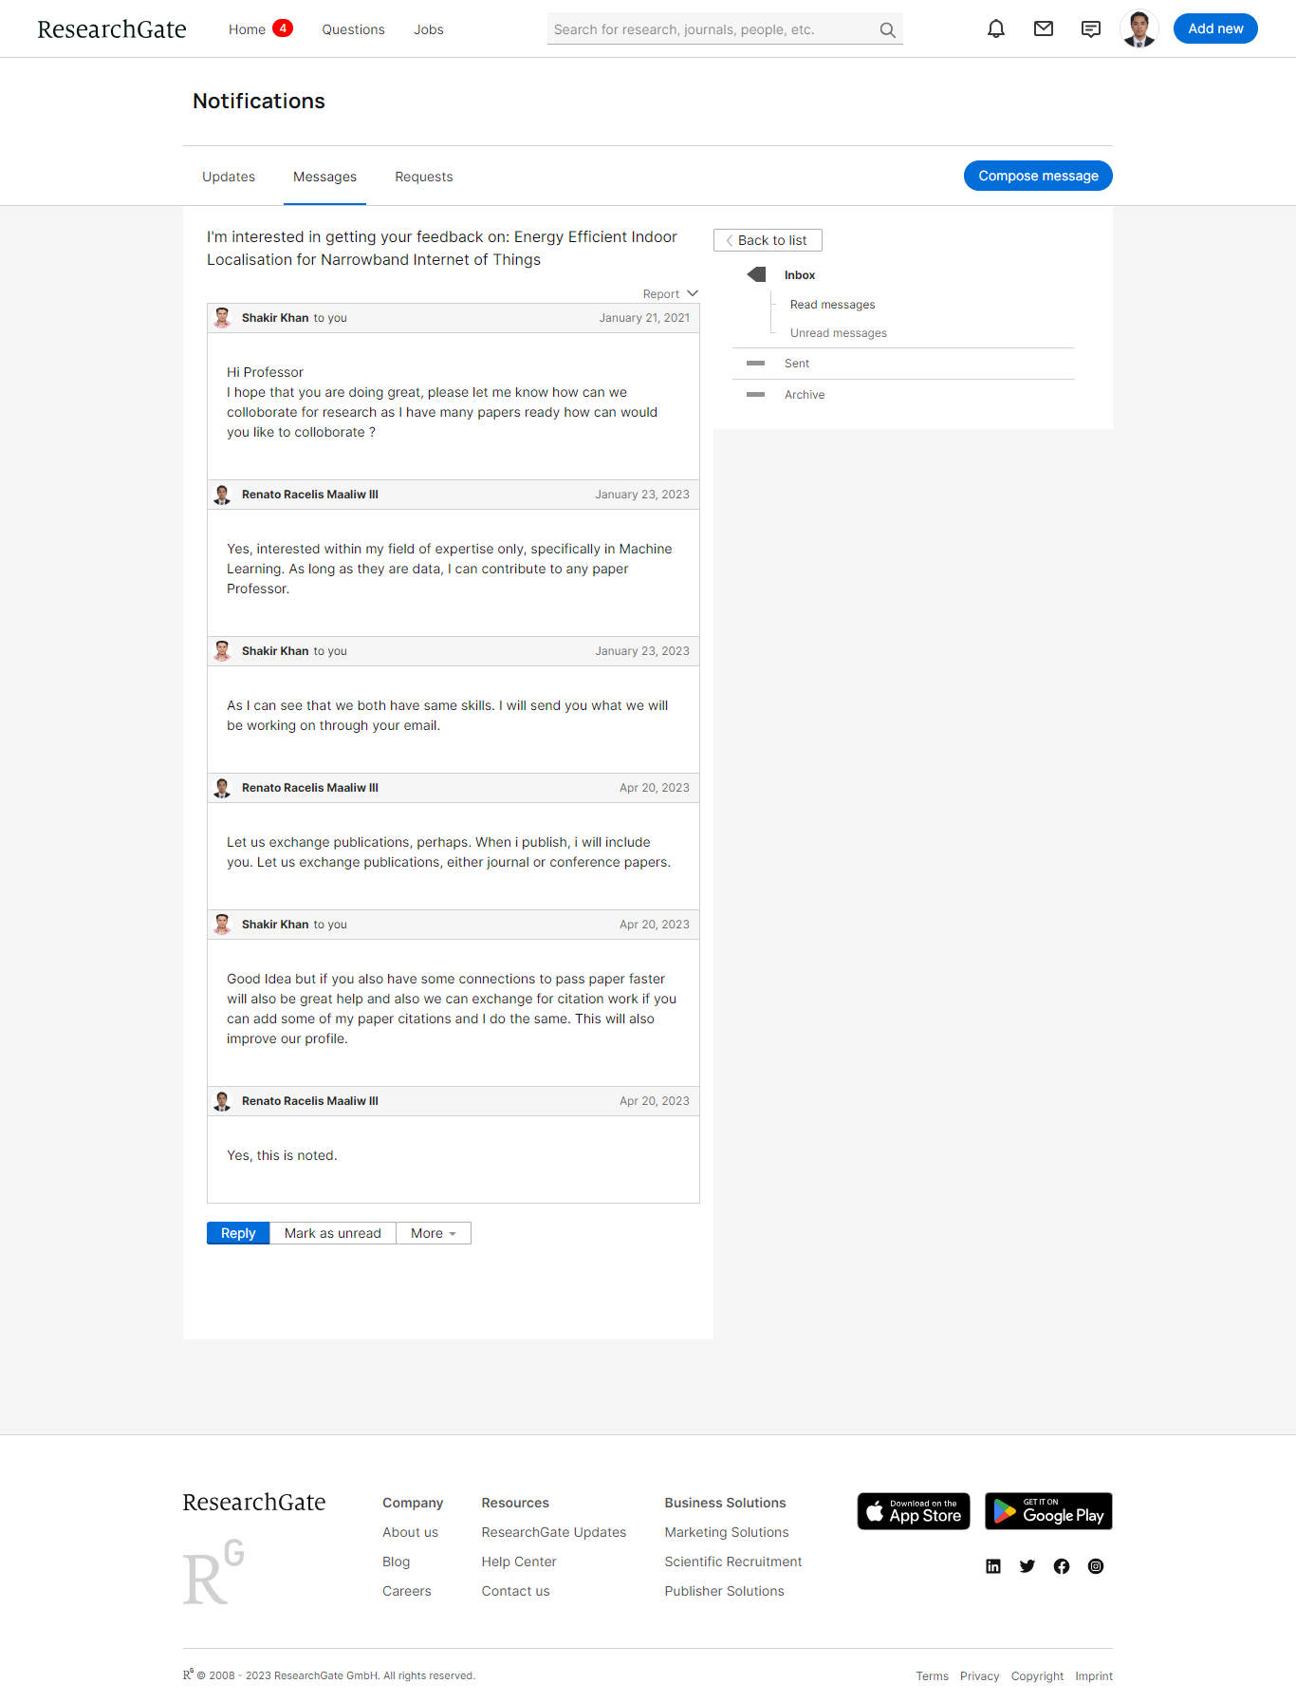**Research Collaborations with Foreign Authors**

**Research Collaborations with Foreign Authors**